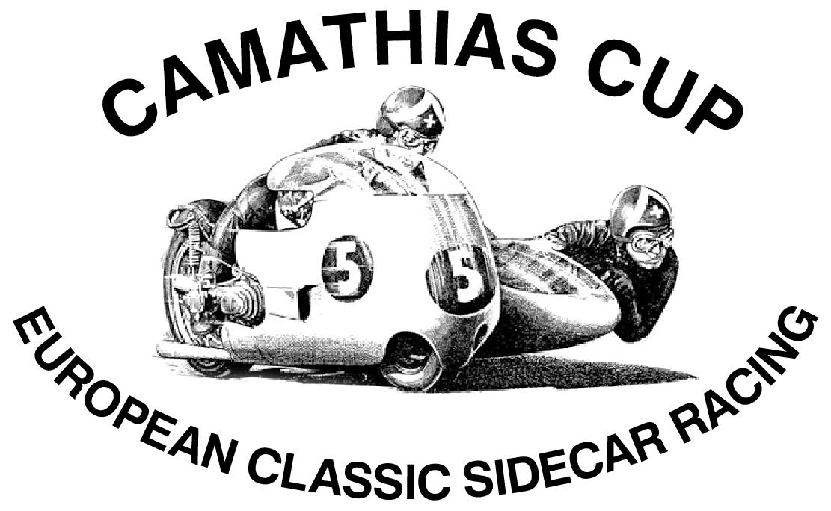
the Camathias Cup Eligibility Rules
General
Interpretation
Decisions regarding the interpretation of these rules rest with the Camathias Committee, Whose decision in these matters shall be final.
Classification
Sidecars will be classified by engine type into Period 2 and 3
All sidecars must be of a front exit type
Period 2 – Engines eligible for “Period 2” will be December 1967 for 2 strokes (restricted to 500cc), December 1972 for 4 stroke, engine limited up to 750cc.
Period 3 – Engines eligible for “Period 3” Multi valve, multi cylinder over 750cc up to 1300cc, Also eligible are car engines from the classic period and any hybrid engine produced in the period to December 1972.
Carburetors
There shall be no restriction to the diameter of carburetors, but they must be of a type and model used during the classic period, Power Jet carburetors are prohibited.
Fuel injection is permitted if fitted to that machine as original equipment .
Flat slide carburetors (except electrons & Gardner type) prohibited.
Gearbox / Transmission
Must be of type and model used during the period of the relevant motorcycle. Must maintain the appearance of external origin. Internal parts of the gearbox can be changed.

Engine
Appearance
The appearance of all parts of the engine must be kept as original, unless it can prove that these external changes date as the reference period. The internal parts of the engine can be modified, but the machine will participate in the class with the correct engine size.
The bore and stroke must be indelibly marked on the engine.

Operating Principle
The principle of operation of the motorcycle history can not be changed, ie : - For four-stroke engines: OHC, OHV, SV, the distribution chain, the angle and the number of valves, tappets, etc..,
For two-stroke engines: piston, rotary intake, membrane, control systems exhaust should be kept as originally produced.

Ignition
There is no restriction on the type or system used.
If non-standard electronic parts are used, these components must be hidden.

Frame
Must be of tubular construction type, The tube shall be of mainly round section, A small proportion of oval, Square or box section is allowable and must give all reasonable appearance of belonging to the classic period. The sidecar must be of Tubular and /or sheet metal construction, if it is not a full frame to be securely attached to the motorcycle at no less than three points.
Front Suspension
The forks must either be telescopic forks (can be replaced by a model according to the time of production of the machine. Telescopic fork tubes with a diameter greater than 35 mm are prohibited) or leading/trailing link design.
Upside down telescopic forks , hub center steering and sidecar wheel steering are not permitted. Suspension must move in a vertical arc in line with the longitudinal axis, with the steering in the straight ahead position. Steering dampers may be fitted of either friction or hydraulic type.
Rear Suspension
The rear suspension can be replaced by a model according to the time of production of the machine. Separate reservoir shocks prohibited. Suspension must move in a vertical arc in line with the longitudinal axis, with the steering in the straight ahead position.

Wheels / Tires
The wheel diameters used 10”, 12”, 13”, 15”, 16” 18” and 19”, Any currently available type may be used, with the following provisos: the width of the tyre must be kept with the period of the machine and in case of 10”,12”, 13” and 15” wheel the width of the tread in contact with the track shall be not be wider than 150mm or 6”, Maximum acceptable rim width is 7”.
Due to the non availability of the Avon crossply tyres for 13” wheels the outfits using these wheels are allowed to use up to 185mm wide radial tyres, eg 185/60-13.
The profile depth of the tread must be at least 1,5mm.
The speed index of the tire must be suitable for the maximum speed of the motorcycle.
The use of slick, slick recut, and recut wet tires is prohibited.
Brakes
Brakes can be drum or disc on two or three wheels. Mechanical and / or Hydraulic operation is permitted, Providing two independently operated braking systems. In the case of Hydraulic braking systems the foot brake will operate two cylinders (This can be either two independent master cylinders or one tandem master cylinder) one of these cylinders must operate on at least two wheels. A brake on the handlebars of a clamp independent brake on the front wheel will be considered a paddock brake. Only 2 piston calipers are allowed, 4-piston calipers are prohibited.

Fairings
May be of “Dustbin" type with a separate sidecar nose tray, or may be of one piece design, but must be of the period style.

General Points
The exterior of the machine and all parts must match the original appearance, as there including size and shape; unless it can be shown that the changes correspond to the period.
Because the machines evolved constantly to improve performance, a test called 'Test 10 not' (or 10 feet), where it is sufficient that the machine is very similar to the original version at a distance of a few steps, is applied. Whereby replicas of frames, parts or complete machines can result in the use of special manufacturing techniques not allowing each piece to be exactly the same two times, be slightly different from the original.
Conventional competitions must have the style and appearance as the reference period during which the machine was built and used.
If a bike does not fit the criteria above and the rider can not prove compliance, The Camathias Committee may take the following decisions:
a) accept in class but "Not Ranking"
b) accept in another class but "Not Ranking"
c) refuse the start
If compliance is proven, the case will be added to the list of exceptions for next season: either keep in the exceptions list or add the criteria.
All teams entering “The Camathias Cup” understand that they can have their engine size tested at any time during the season.
2 GENERAL SAFETY RULES
All motorcycles must comply with the rules below, unless otherwise stated in Regulation ("Specific Rules").
2.01 Hands must not touch fairings or other parts of the motorcycle when on full lock.
2.02 Tanks mounted on the sidecar must have protection preventing contact with the ground and protection from freely rotating parts
2.03 All drivers must be connected to a cut out system so if they leave the motorcycle the ignition and fuel pump (if fitted) will be disconnected.
2.04 Oil catchment trays must be fitted under the engine of all sidecars
2.05 All hazardous DIY may result in non-compliance of the motorcycle. Failing to comply with safety rules means the vehicle will not be allowed to race.
The Technical Delegate who finds a breach of the vehicle and concludes that this failure can be dangerous for the rider or someone else notify the Race Director who with consultation may possibly remove the machine from the competition
2.06 Fuels. commercial fuel or avgas aviation gasoline are allowed. If methanol is used, the obligation to stick a sticker "Methanol" on the tank.
Eco Bio Ethanol fuel is allowed.

